IN THE Western District of Washington
1717 Pacific Avenue, Room 3100
Tacoma, Washington. 98402-3200; (253) 882-3800 ____________________________________________

Plaintiff:

First Middle of the SURNAME Family

v.

Defendant:

THE UNITED STATES OF AMERICA

On and for the behalf of the United States
_____________________________________________
First Middle
Any Address
Seattle, Washington. ZIP (phone)
Petition for Proper Process Service

Dear clerk;

Please file this claim in a miscellaneous case. This is demand for lawful money pursuant to Title 12 USC §411. A $49 USPS money order is enclosed instrument #XXXXXX Additionally USPS money order instrument #XXXXXX will be mailed by Process PROFESSIONAL, Professional Process for paying Monumental Process Service for hand delivery to the offices of Janet Louise YELLEN as US Governor of the International Monetary Fund at the US Treasury building in Washington DC.
This process and filing should be brought to the attention of Robert J. BRYAN, oath attached.
Attached please note the frustration with the US Treasury evading process. After six months the USPS is shown to be in collusion with the arrest of process and service of process. Therefore this miscellaneous case is intended to provide PACER publication, on and for the behalf of the United States to show some honor, and that the obligations of First Middle have been fulfilled - They shall be redeemed in lawful money on demand at the Treasury of the United States...

______________________________
First Middle

Original signed 1040 and a hardcopy of this pdf from PACER have been mailed or delivered to:

Process PROFESSIONAL
Professional Process
1234 Somesuch Avenue South
Tacoma, Washington PROCESSZIP

With payment and instructions to serve the document package to:

Monumental Process Servers
823 Martin Luther King Jr. Blvd
Baltimore, Maryland. 21201

To be served by hand upon:

Janet Louise YELLEN
US Governor of the IMF
1500 Pennsylvania Ave NW
Washington, DC 20220
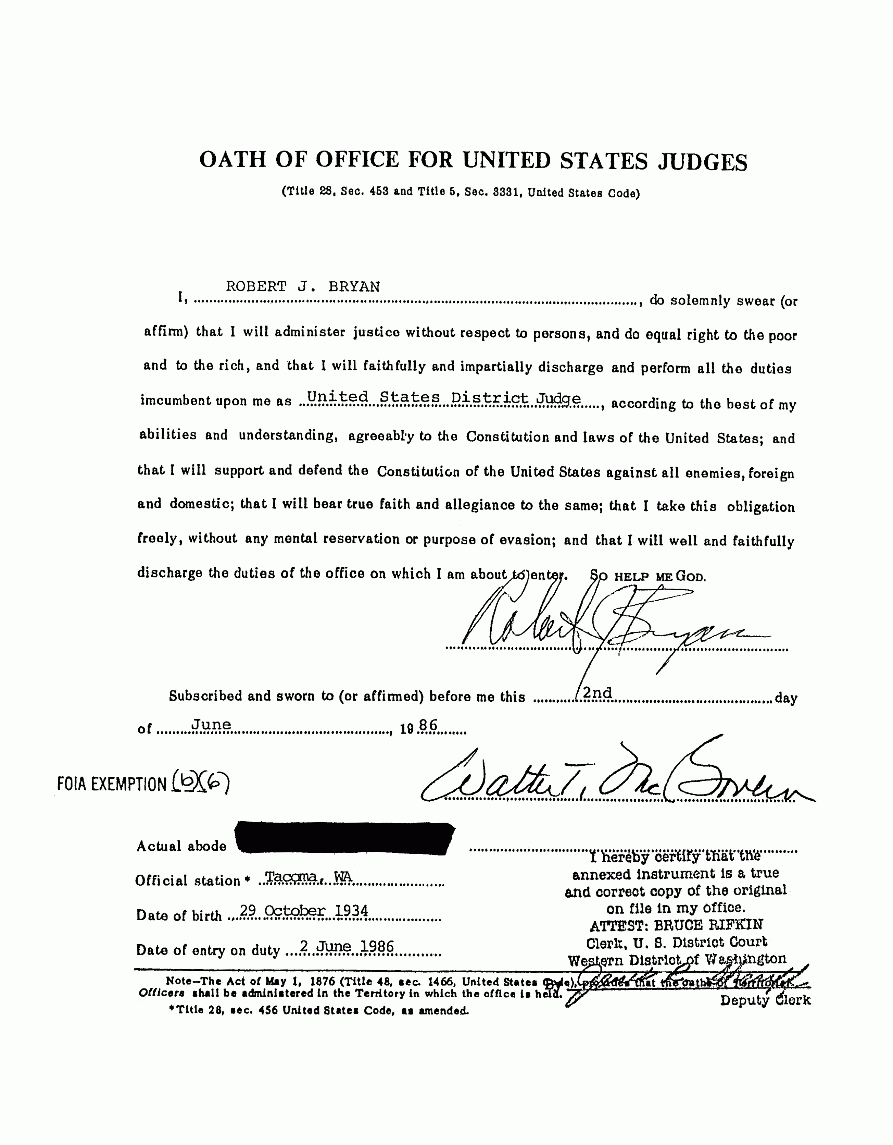
It is noted that this oath has been altered - "So help me God." is deviant - "SO HELP ME GOD."
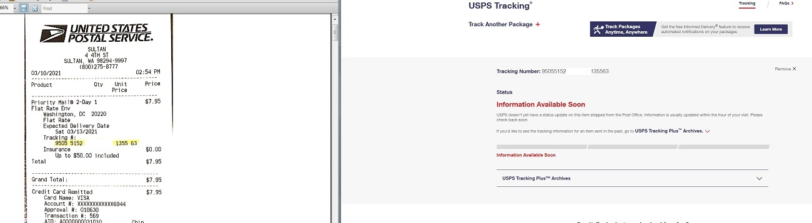

Empty promise of the USPS. USPS Priority Mail #9505 5152 XXXX XXXX 1355 63 may have been delivered, maybe not. There is reason to believe that the US Treasury is evading its obligations at the mail clerk by colluding with the USPS to obscure vital process service information.

