COVID-19 and the Generation of Novel Scientific Knowledge
Lucie PERILLAT and Brian S. BAIGRIE

A generation is twenty years. But it took seventy years for Nebuchadnezzar to create the Jew. Genetic engineering as an art is best a happy accident.
Nebuchadnezzar's (including Cyrus and Darius) was to cultivate the black hole generated in the coherent Meissner Field of the Israelites, the Ark being a transition metal interdimensional charge compressor (Delta Q being where memories reside) powered by ORME - Orbitally Rearranged Monatomic Elements and gold being the endocrine correspondence for the pineal gland.
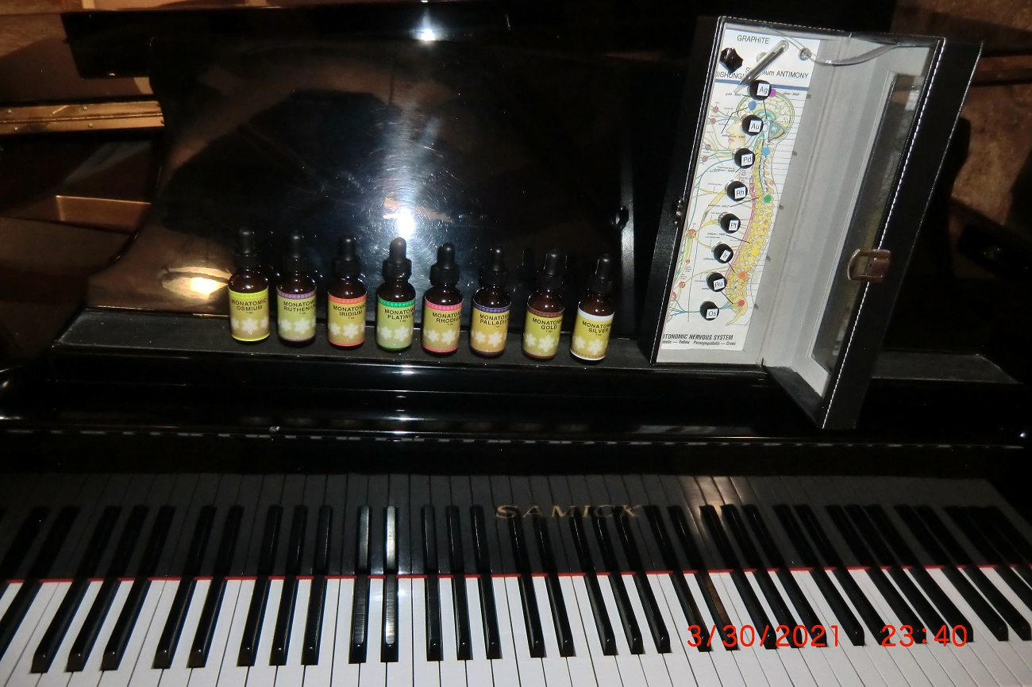
The Paper subject commentary drew me in right away. The hydroxychloroquine HCQ was my carry over from 2016. Donald John was born wealthy from his grandfather and father colonizing quinine. Since DJ was spouting HCQ and even used it to reduce his own COVID to the weekend flu Hunter made China an offer of back door entry into NextDoor, FaceBook, Norton and Avast etc. Public notice ran through Wikileaks from a "stolen" (planted) hard drive outlining the offer. This put Joseph Robinette JR in the Oval Office. It is easy enough to simply retrofit control algorithms into the mining operations. Especially with puppet Russia online, one could even find a lost cat in Denver from the Kremlin. And with the camera in the bedroom, even tell you if the cat is really lost or hiding under the bed!
You may sense what I say is true if you are Jewish, with remnants of the supersoldier Israelite still active in the remains of your genome, supposing you have been good about being inoculated with the NAV (nucleic acid vaccine). Those parts that are still human might remember the first coronavirus around 20,000 BC as the Ark tech (ARCTEC) went online.

Russia (above) - China (below)
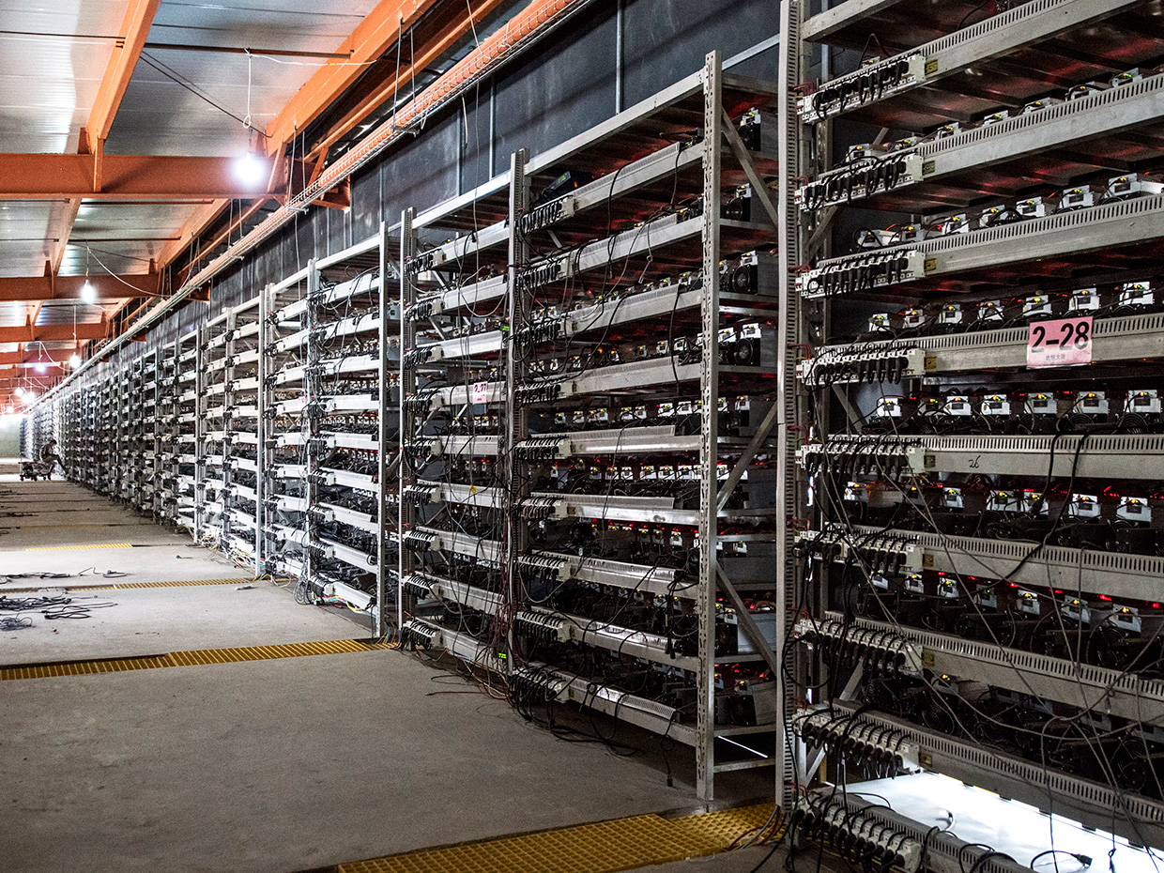
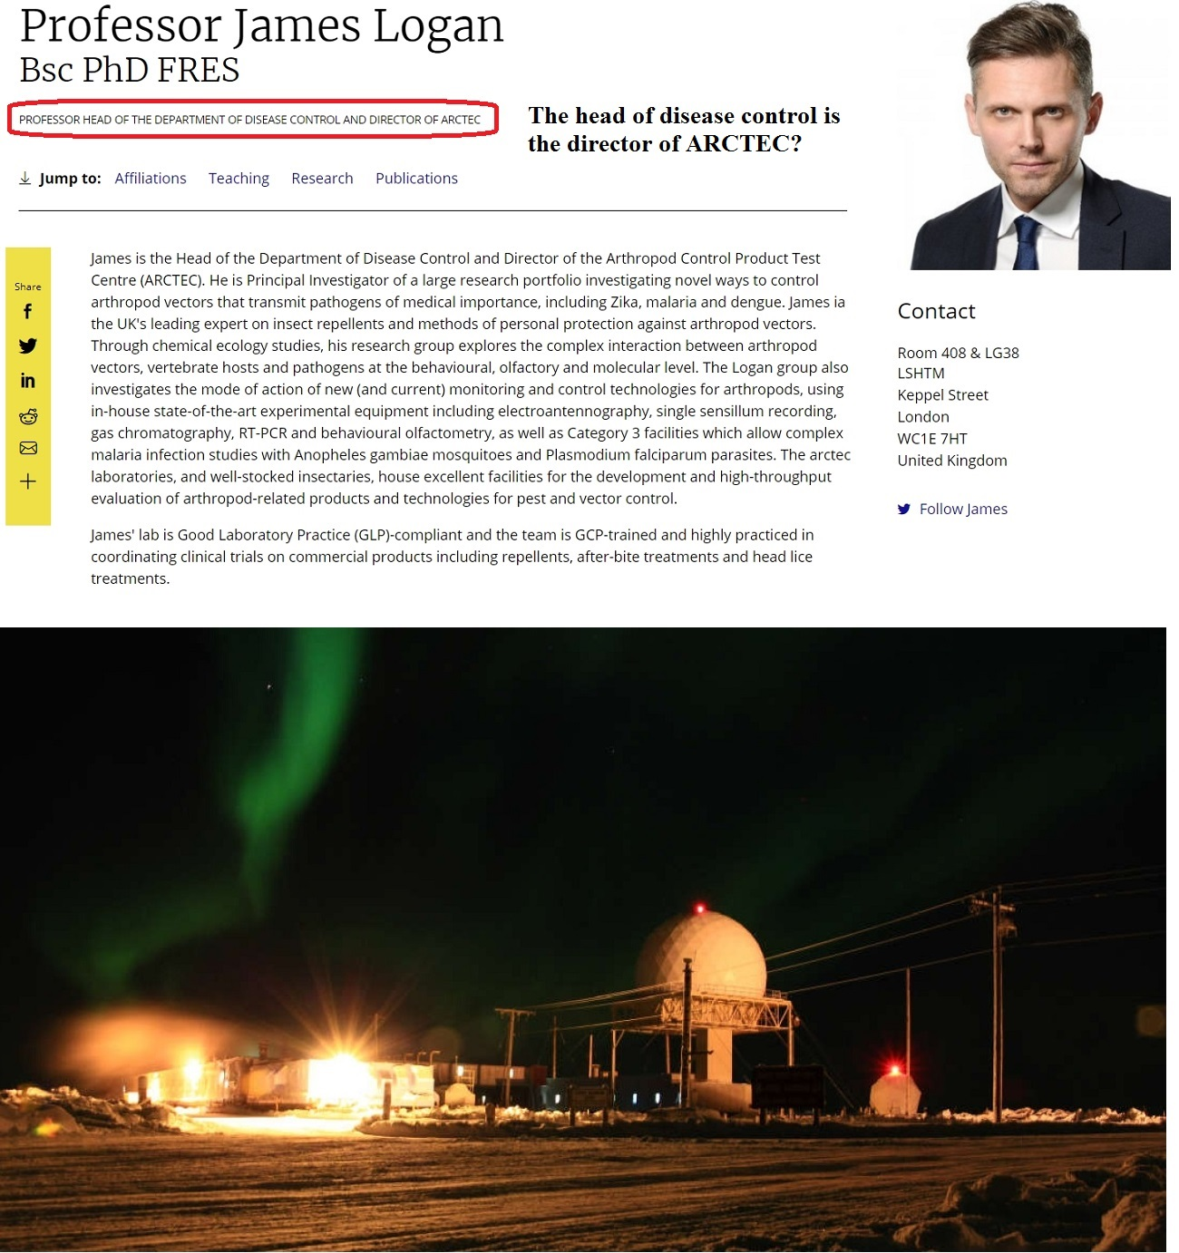
If you are aware, and have been watching JR talk you can see the fellow can barely think, as he implements my project Culling the ignorant, stupid and gullible. He obviously has taken the Koolaid - both injections. DJ said he would be back.
Every time a new radio technology comes online, at rollout it drives enough DNA damage to excrete RNA in mass. The Invisible Rainbow - The History of Electricity and Life is an interesting read.
So here I might turn to my patent US #10,999,999 from 2003 - gene sequencing under title - Eradication of SARS.
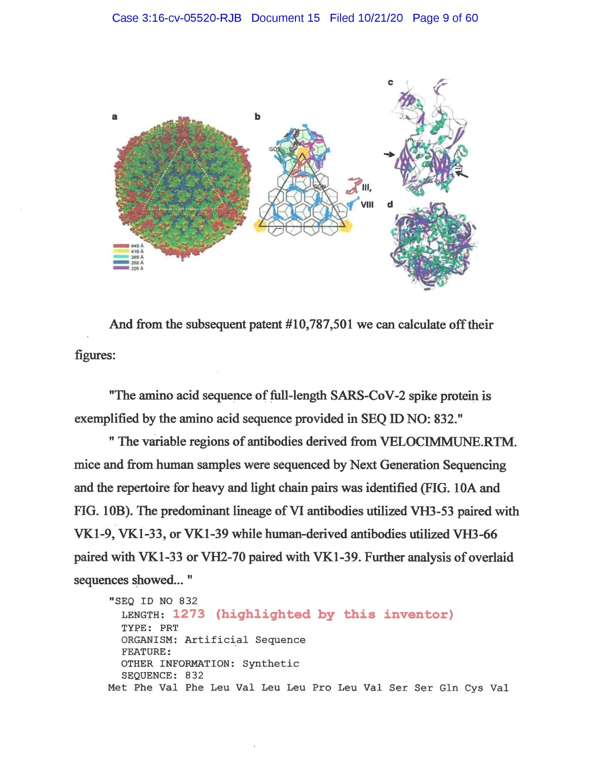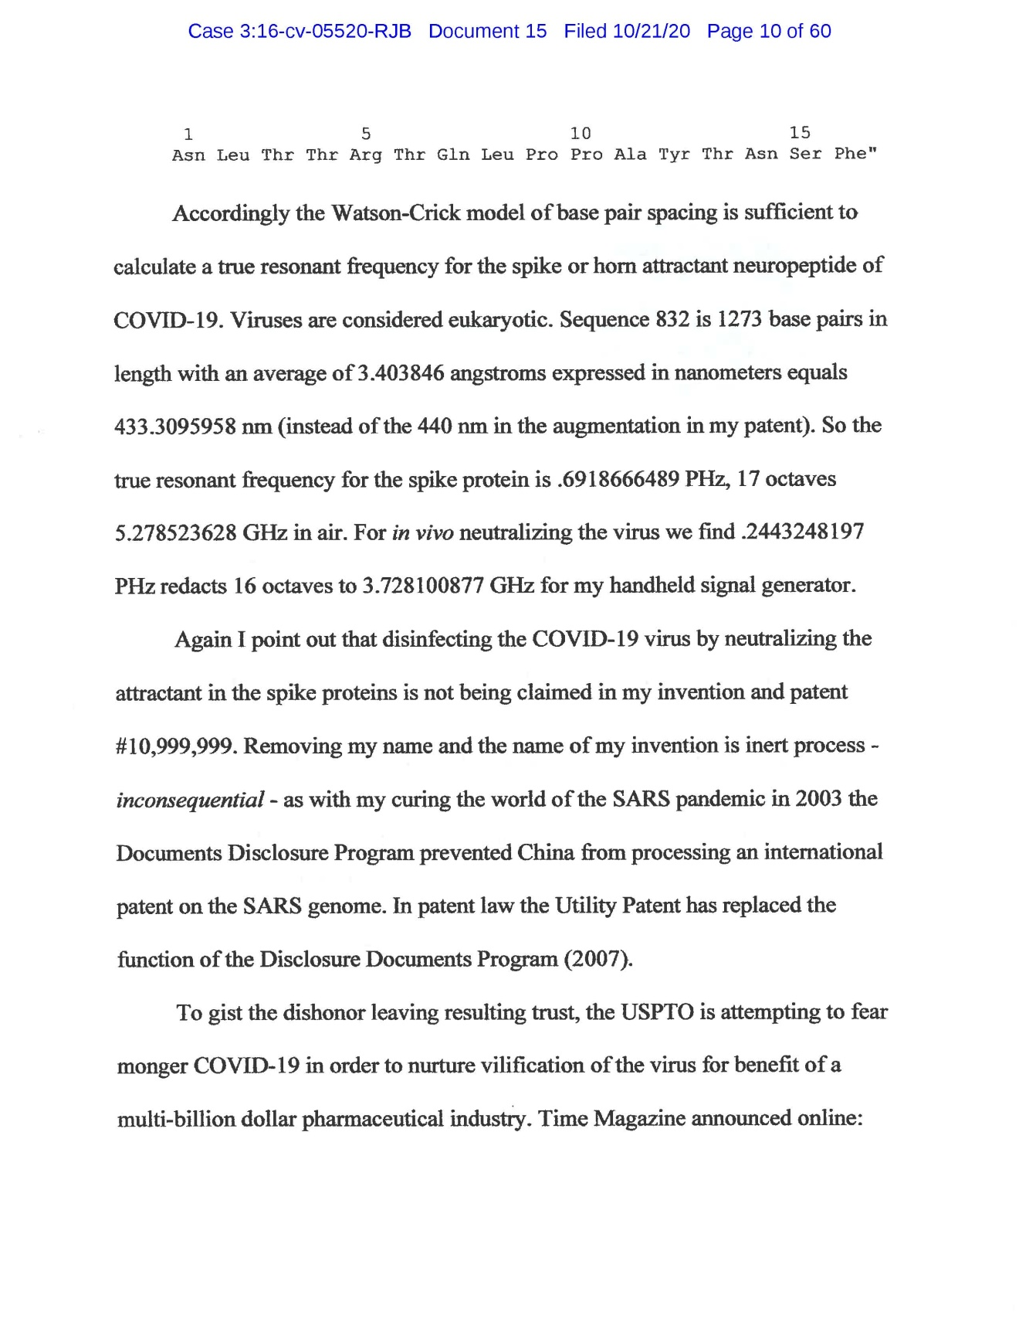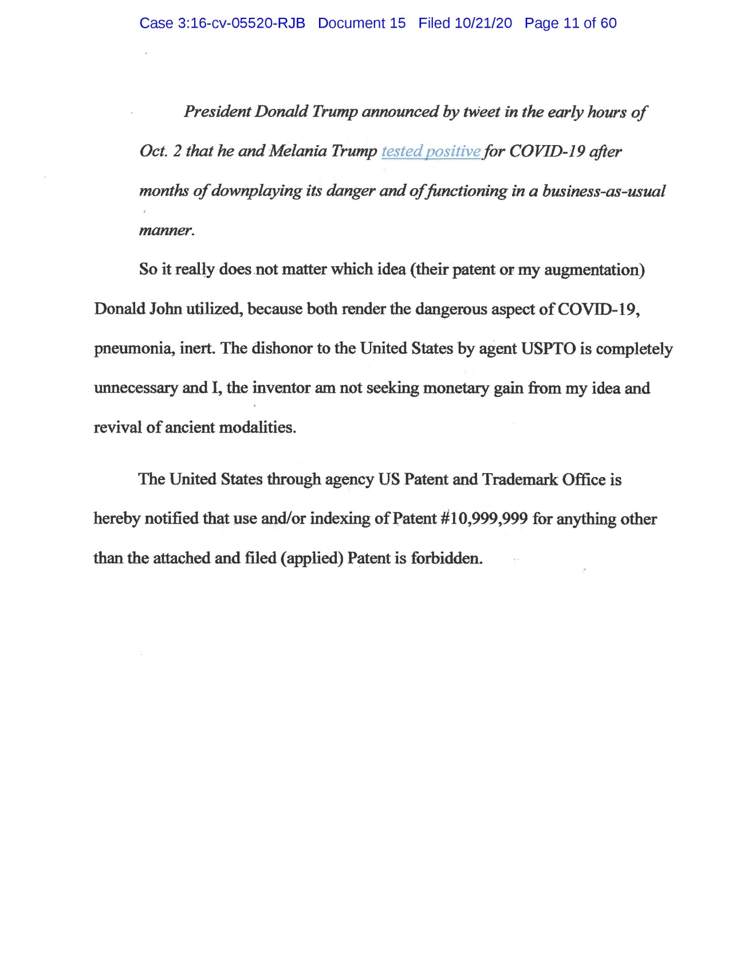
Above is nothing but factoids on the record. My opinion is that the paper minus my play on GENERATION just barely scratches the surface about being blinded by material science. I think most significantly is the Council of Trent where the Pope decided to let us be in our Science Labs as long as we left things of God to God - CASTLE CHURCH - For the Redemption of the Office BISHOP. The Bishop of Rome is the Pope, short for Puppet. The Council of Trent left the Pope judge of what belongs to the world of science.
The COVID-19 Vaccine has been online for years now and my filter, to clear out the noise pollution is set in stone, quite literally. Just scroll down a few pages, to my Keep. The love and wonder of the people is instilled in each stone.
Can you feel it?
Where you scientists went astray was in 1985 we discovered carbon 60 and you never even thought we should add that into the periodic table. Teachers still teach the incorrect rendition of chemistry.
This is what made it so easy for Pfizer Japan to keep the lab rat testing CONFIDENTIAL. The Culling may never have become immanent had people known the lipid nanoparticles migrate into the bloodstream and are absorbed by the ovaries and bone. 917 miscarriages reported by CDC in one week? What is astounding is how you all, those losing awareness, missed Page 39 of the Safety Protocols! JR is already attention deficit - just look at him. He can barely focus on the prompts.
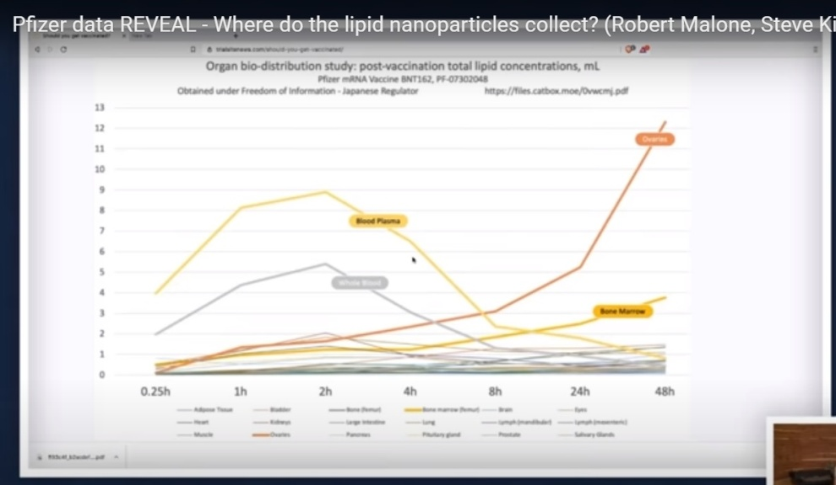

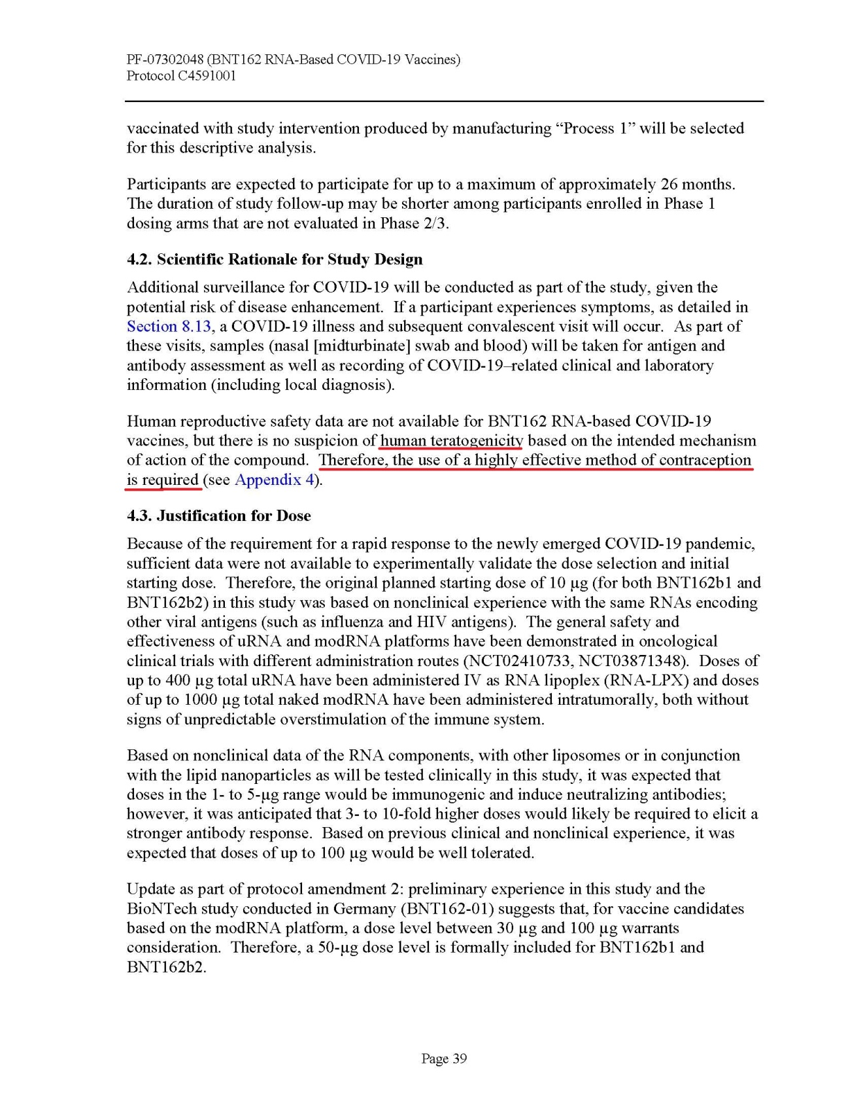

Bless this immunity! My identity confluence of two ancient dynastic Sumerian bloodlines is not preserved by the mask; I have wrapped my DNA tip to toe in corresponding transition metallofullerenes. The other day a nosey homeless man wanted to know why I was hanging around his strip mall. He asked, "What are you building today?" I was taken by surprise. "I am not building today." He prodded, "I thought you were building today." He imposed false authority. I replied, "I am geopolitical social engineering." He went blank, "What does that mean?" I responded, "I am building tomorrow." He decided he was out of his league and walked away.
It is simply refusing for cause scientifically to preserve the planet rather than to exhaust it.

Potential for mRNA vaccines
to Cause Covid 19 variants
B. Daunter

Covid 19 belongs to the group of RNA viruses that lack DNA. For the virus to produce the surface proteins, spike proteins, that allows the virus to enter host cells, it uses the host cell’s metabolic pathway for protein production. This is achieved by the viral enzyme reverse transcriptase that transcribes the viral RNA into DNA. This DNA is incorporated into the host cell DNA for translation into mRNA for producing the viral spike proteins. This pathway is bypassed by the vaccine supplying the mRNA. However, the potential exists for the mRNAs to be spliced together and incorporated into the viral RNA. The resulting viral particles will infect other cells but will produce viral particles with different spike proteins. That is new variants that require new vaccines.
COMMENTARY:
Hi Brian;
I am a geopolitical social engineer and inventor of gene sequencing under the title, "Eradication of SARS" (2003). So to juxtaposition your own and colleagues' perspective will render freakish interpretations.
I tend to agree with your hypothesis but think maybe I am overlaying my own quote, "Delta Variant is a catch word for any Adverse Event." What I mean by that is that the NAV, and we shall not call it a Vaccine, causes some major blood disorders including by the CONFIDENTIAL Pfizer rat biopsies both yellow and red bone cells are secondary attractive targets for mRNA, after the matrix (ovaries). I am throwing a link to show an example,
https://drive.google.com/file/d/1WoQQl_6ZweYjLmMK0pHgm_vPUjIcHdj2/view?usp=sharing
This is achieved by the viral enzyme reverse transcriptase that transcribes the viral RNA into DNA.
Originally I focused straight on spike protein being attracted especially to type-2 pneumacites (alveoli) and the intelligent design with a capsid antenna at 5.048 GHz, located in the center of the 5G streaming intelligence of medical conference calls for example. And quite possibly expert as you are you might be better off to think the RNA and DNA are only clever on some fundamental base chemical process called mitosis. As I explain in my reiteration of the 2003 patent around COVID-19 the instinct for survival kicked in with wealthy elite diners in Wuhan, butchering the animals slowly, live in the kitchen to drum up an adrenalin flurry in the raw meat. Mix that struggle in gastric juice directly under the new 5G rollout repeaters.
Here are some findings from my laboratory that may interest you:
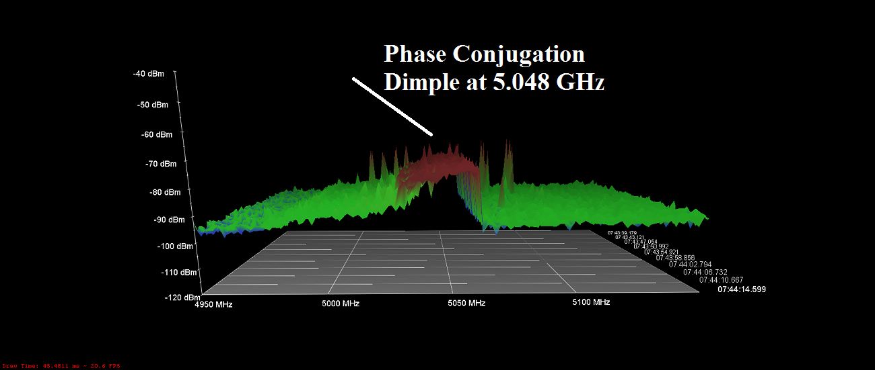
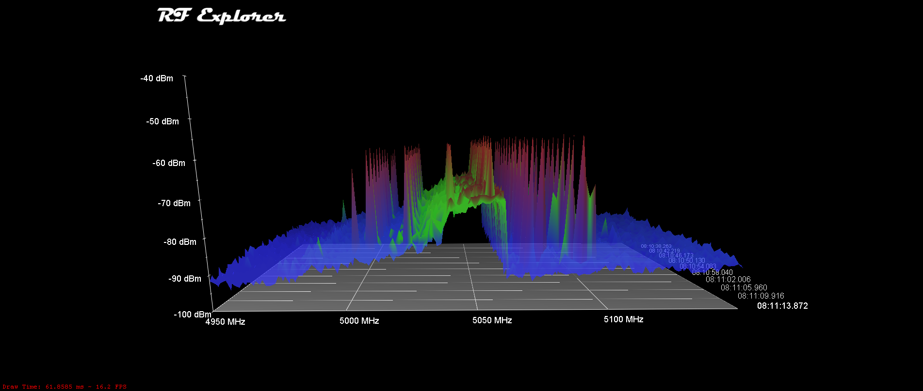
The 5.048 phase conjugation dimple was predicted from classic COVID-19 but understand that it is a Van Allen Belt broadcast in retaliation to my invention, Waggle, or Tickle the Capsid. So when I went online from my filtered antenna array in Colorado COVID-19 worldwide broadcast 180° out of phase in a futile attempt to stop the devitalizing powers in the signet, that I developed in 2003 against coronavirus in general.
I want you to consider some of the extraordinary blood disorders in the videos I am showing you, and you should duplicate them before they are taken down.

https://beforeitsnews.com/health/2021/07/bill-gates-gone-into-hiding-as-vaccine-deaths-skyrocket-boosters-coming-in-september-banned-must-video-3040554.html
In particular look at the hemoglobin disorder demonstrated in this video. The young woman's injection site (5:40 Minutes) is highly magnetic.
https://beforeitsnews.com/health/2021/07/bill-gates-gone-into-hiding-as-vaccine-deaths-skyrocket-boosters-coming-in-september-banned-must-video-3040554.html
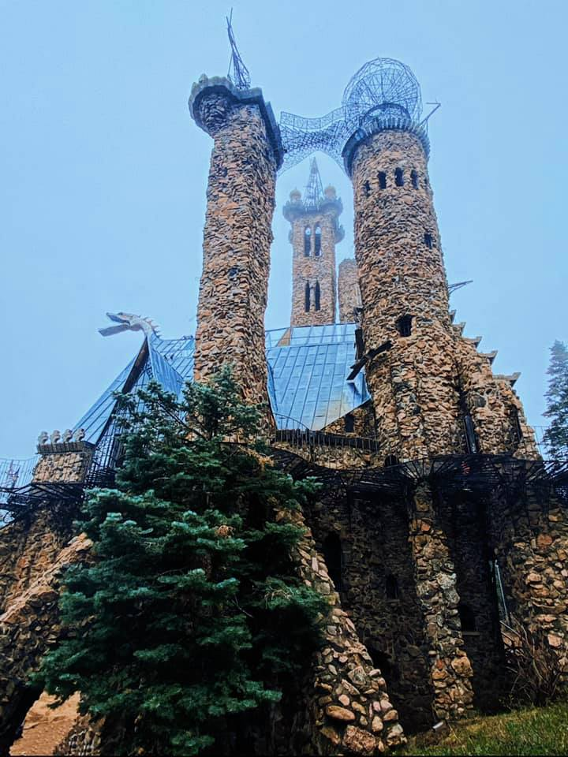
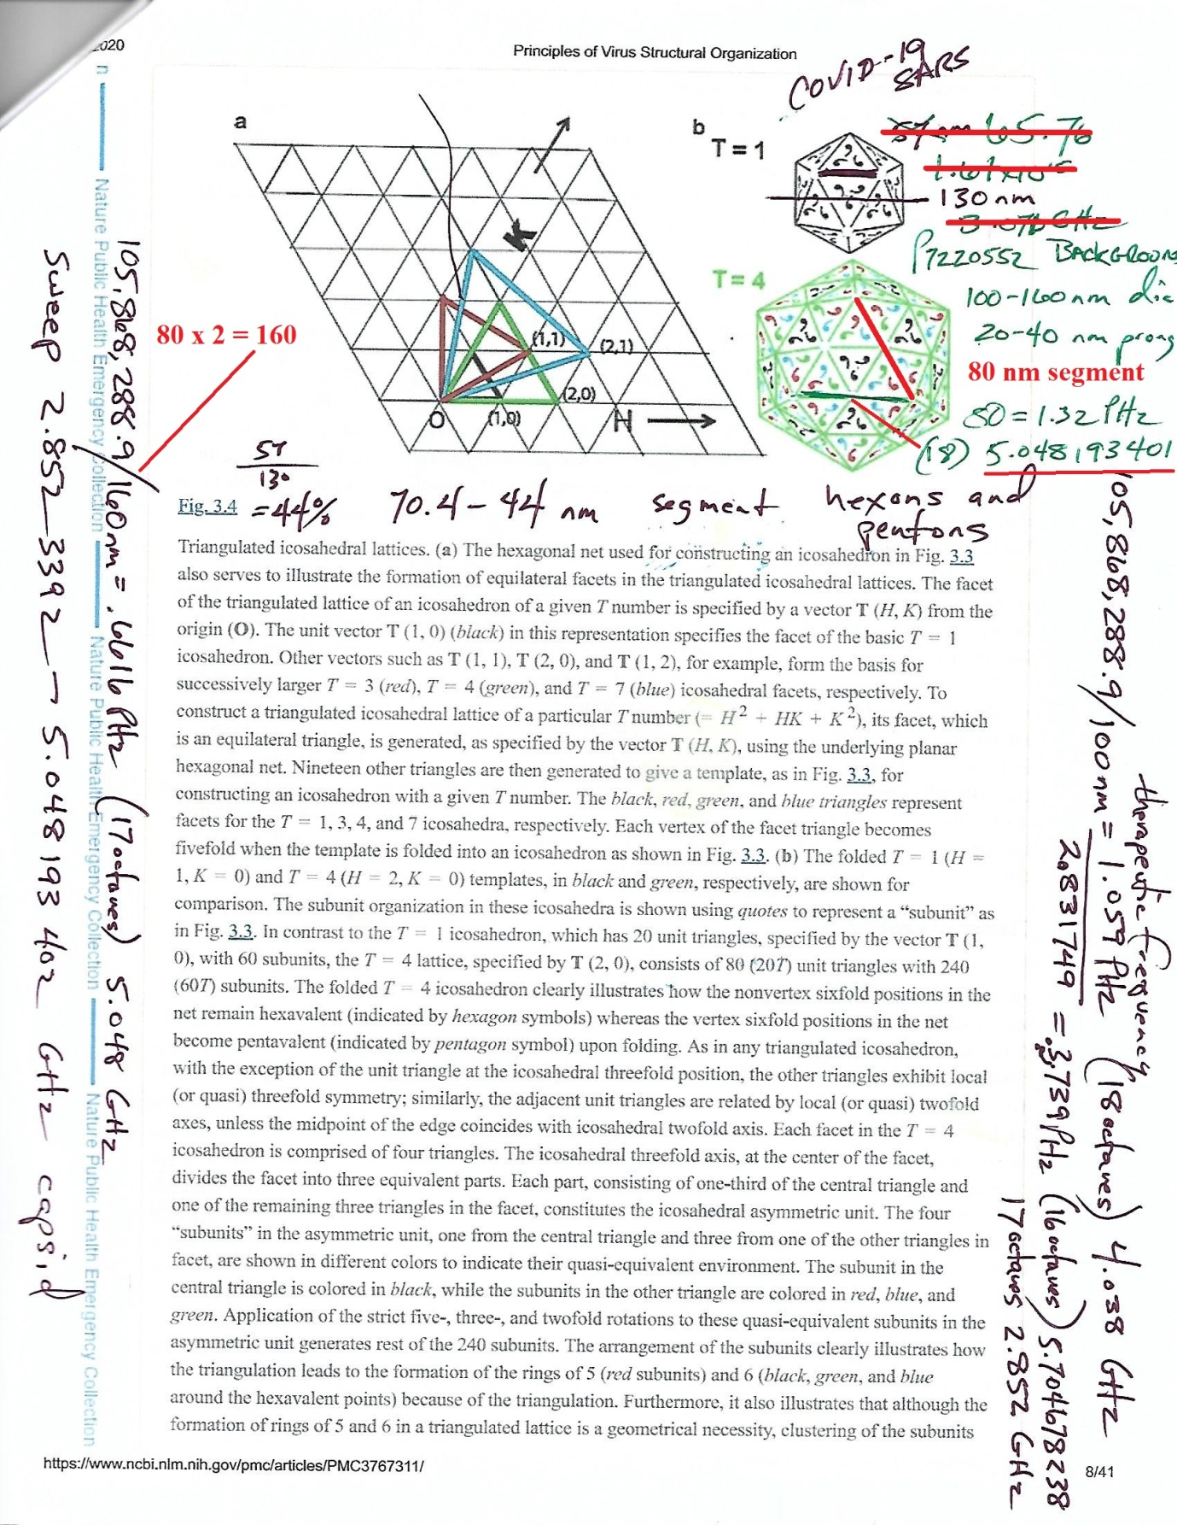
Sorry if I am long-winded.
My point is that your hypotheses will never meet any kind of scientific testing in light of mine. There is no segregating any datum amidst such a chaotic experiment in transhumanism.
So I concede to your hypothesis in the same manner that Jeff GOLDBLUM in Jurassic Park proclaimed, Life will find a way. Sure enough, the female velocorapters developed reproductive capability. Frogs do too.
So my interpretation of your hypothesis is that the RNA will seek the eukaryotic cell for reproduction chi energy. Maybe this same instinct will drive RNA to seek becoming DNA? Might that be close to what you are saying?

