IN THE Western District of Washington1717 Pacific Avenue, Room 3100  Tacoma, Washington. 98402-3200; (253) 882-3800 Judge Robert J. BRYAN  ____________________________________________  Plaintiff:  David Merrill of the VAN PELT family  v.  Defendant:  THE UNITED STATES OF AMERICA  _____________________________________________  David Merrill  720 N 10th St; STE A  Renton, Washington. 98057 | 16-cv-5520
Notice of United States Patent #11,999,999
THE TRIGGER

COMES NOW David Merrill of the VAN PELT family AM I. This action is on and for the behalf of the people and planet Earth.
This is the application of US Patent 11,999,999; not an application for US Patent 11,999,999. This invention and my Natural Vaccine, Doc 15 herein, are both related to my 2003 Invention "Eradication of SARS" - USPTO Documents Disclosure #531812. Docs 19 and 20 - Final Judgment - herein describes and defines proper Notice in good faith, that a much better path could have been taken by humankind.

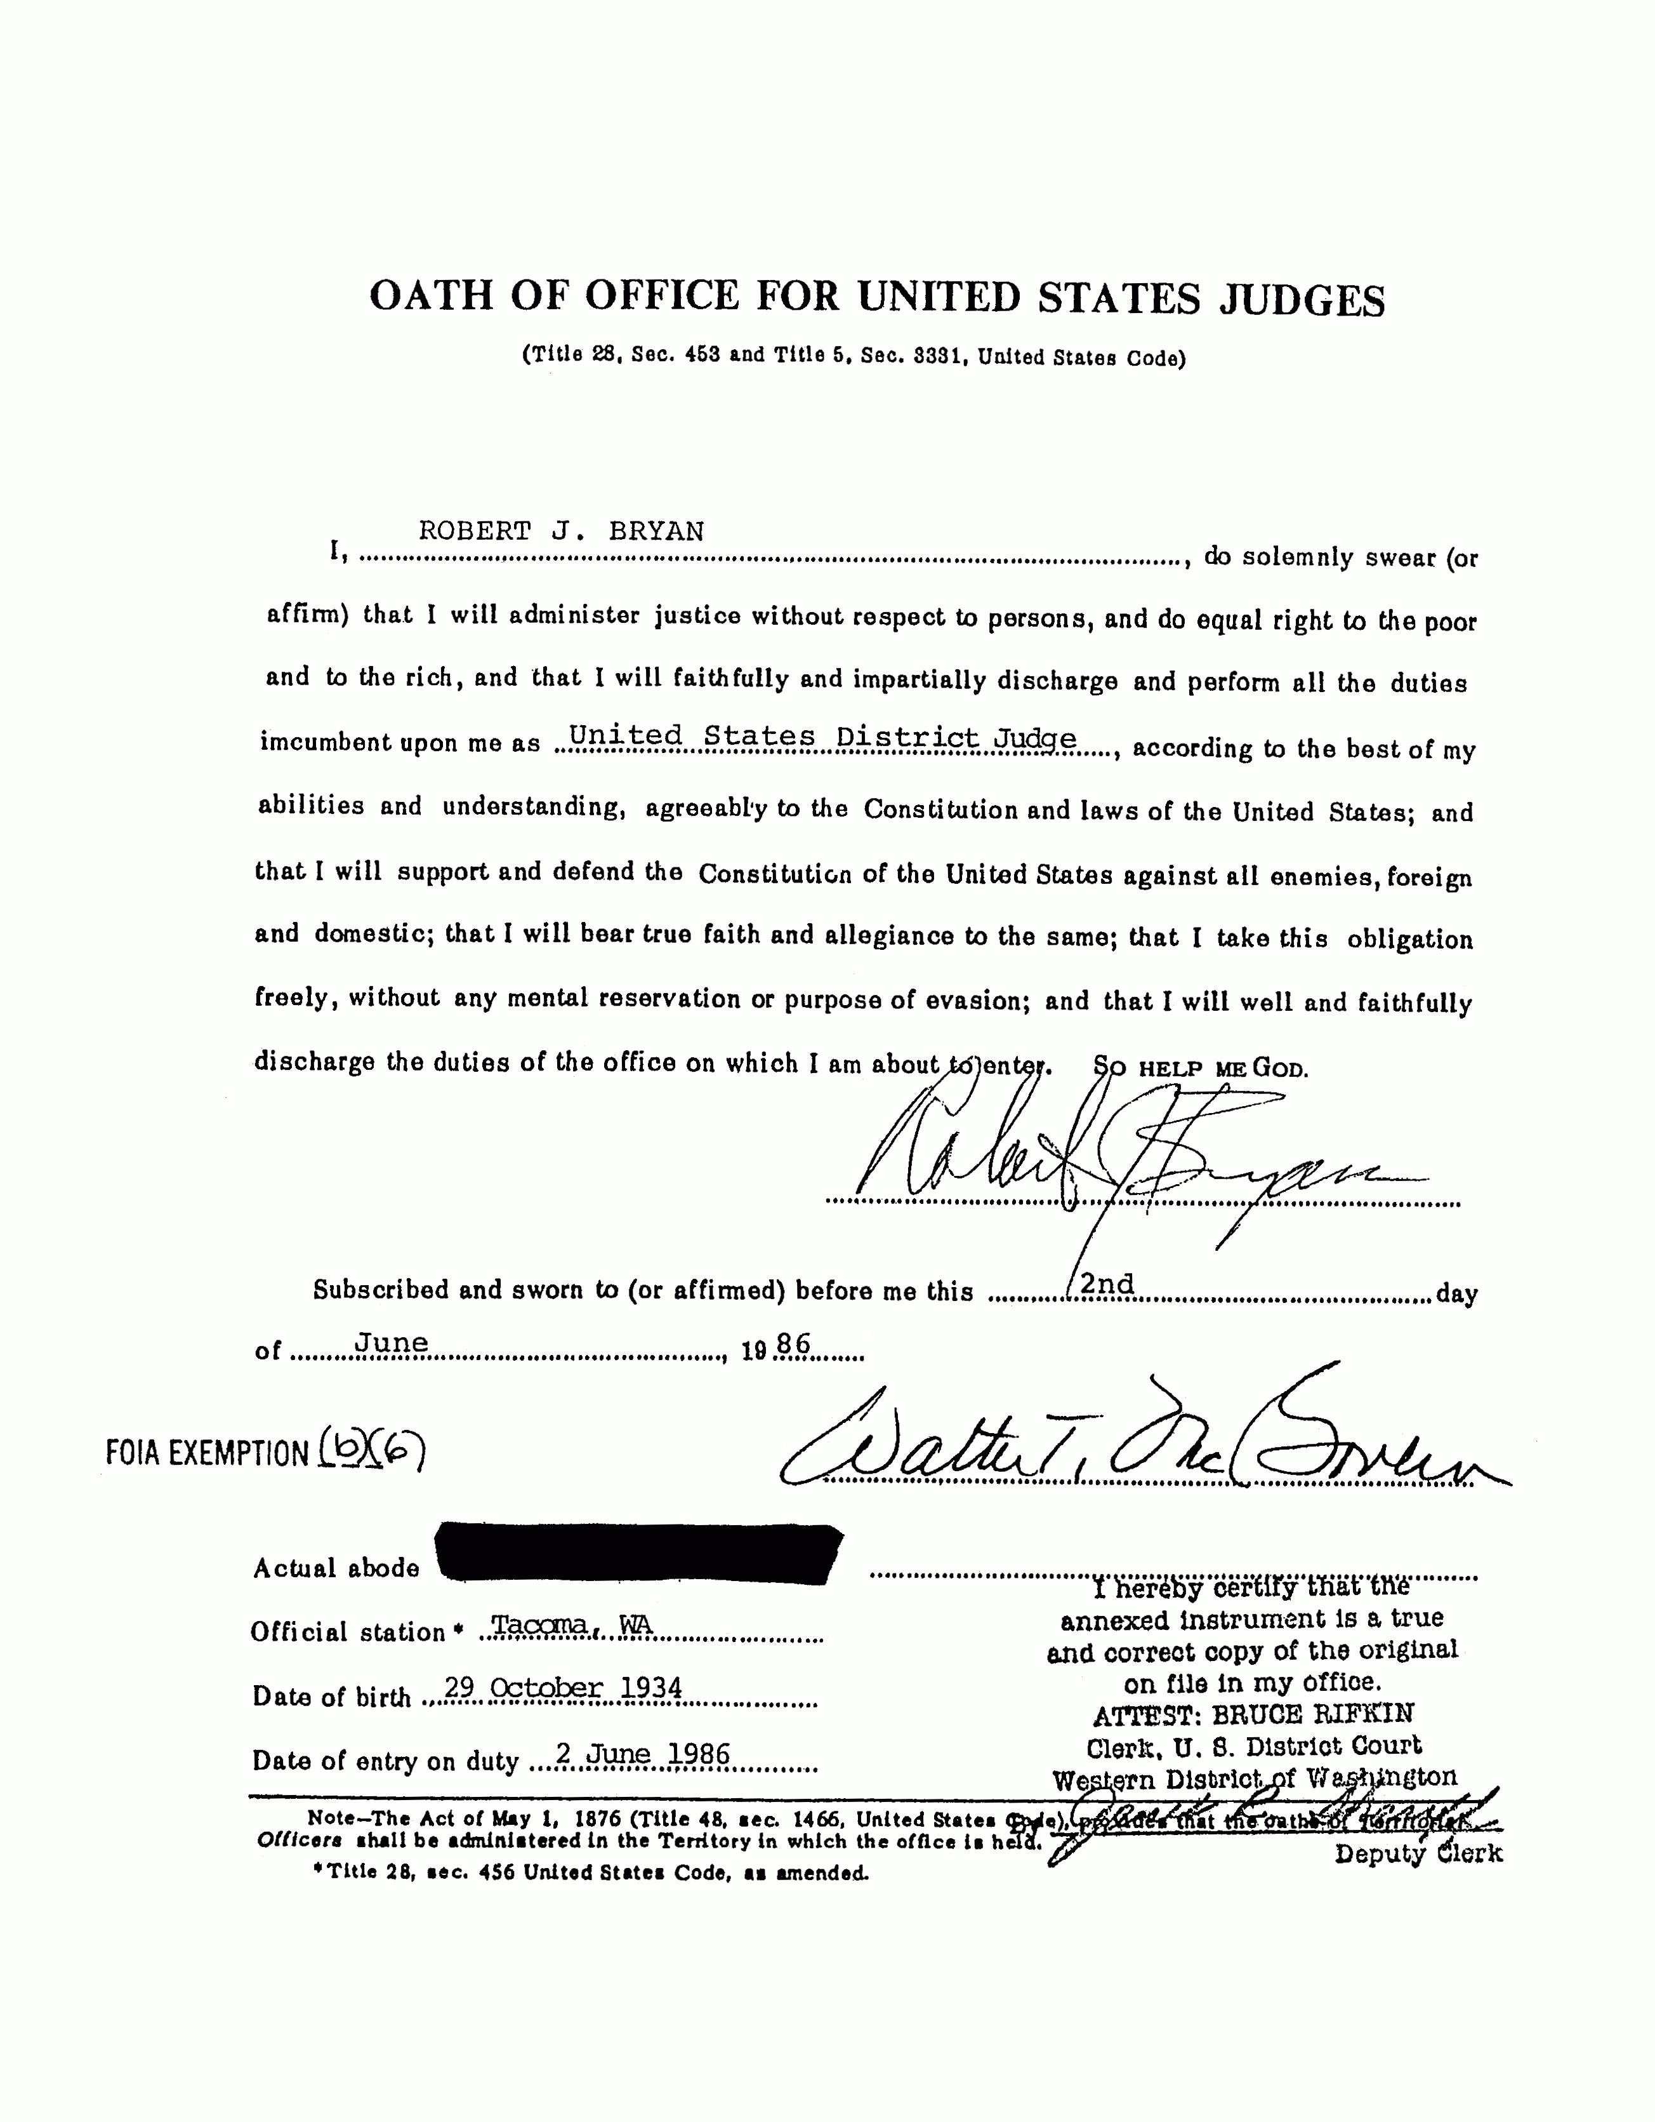
Note this oath of office is deviant in form - SO HELP ME GOD.
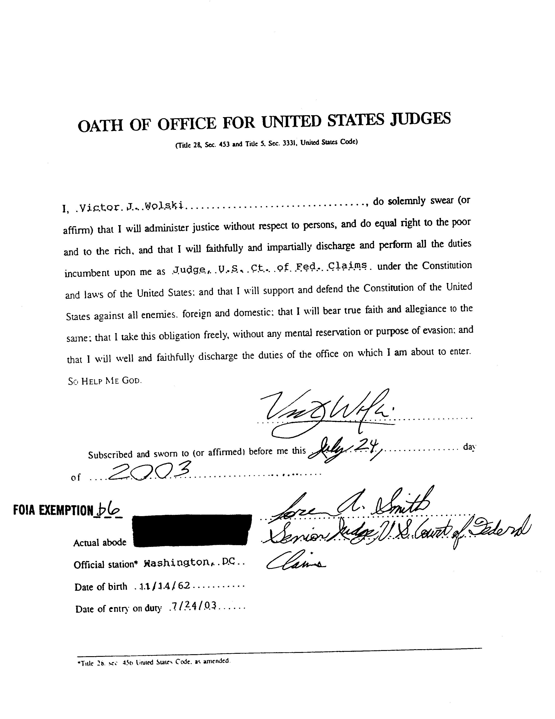
Note this oath of office is deviant in form - SO HELP ME GOD. Re: 15-cv-1416.

United States Patent Patent No.: US 11,999,999
David Merrill Date of Patent: Dec. 21, 2021
_________________________________________________________________
METHODS FOR IGNITING RAPID AND MASSIVE CULLING OF VIRAL HUMANITY (DEPOPULATION), SELECTIVELY THE EXTERMINATION OF THE NAV (Nucleic Acid Vaccine(s)) INOCULATED ALSO KNOWN AS TRANSHUMANS

Inventor: David Merrill of the VAN PELT family, 720 N 10th St, STE A, Renton, Washington. USA 98056
This patent application occurred on the same day, 12/21/2021, Rock Solid Process served it on the President of the United States.
Prior publication data: Doc 15 herein case #16-cv-5520 - COVID-19 Vaccine - Natural, Nonintrusive and Safe; Reviving the Ancient Modality of Healing and Preventing Disease, and the return from the US Patent and Trademark Office of Documents Disclosure #531812 - Eradication of SARS. As applied in 2003 the COVID-19 virus in any variant form is no threat but slight and only to the elderly and infirm. The pathogen is the spike protein in the NAV.
Other Publications: CONFIDENTIAL Pfizer publication - BNT162b2 5.3.6 CUMULATIVE ANALYSIS OF POST-AUTHORIZATION ADVERSE EVENT REPORTS OF PF-0732048 (BNT162B2) RECEIVED THROUGH 28-FEB-2021
USDC Northern Alabama Case #21-cv-702 Doc 32 Amended Complaint. Docs 24 & 25, testimony of the US through Agency.
Crystal Structure of the Thrombospondin 3R6B Type 1 Repeats - PTB (Protein Data Bank) DUQUETTE et al. No mutation. Length 153 See John: 21:11. https://www.rcsb.org/structure/3R6B
Crystal Structure of Human Plasminogen Catalytic Domain - PTB WANG et al. Mutated.
The Researcher's Guide to Mechanisms of Cell Death. Cell Signaling Technology.
Watch Crypto Expert Explain Blockchain to Congress - YouTube video at https://youtu.be/pSTNhBlfV_s and https://www.tinyurl.com/MuskMachine
A PHASE 1/2/3, PLACEBO-CONTROLLED, RANDOMIZED, OBSERVER-BLIND, DOSE-FINDING STUDY TO EVALUATE THE SAFETY, TOLERABILITY, IMMUNOGENICITY, AND EFFICACY OF SARS-COV-2 R4NA VACCINE CANDIDATES AGAINST COVID-19 IN HEALTHY INDIVIDUALS; Pfizer Protocol C4591001 page 39 Rationale about teratogenicity.
Japanese rat testing about the migration of lipid nanoparticles (spike proteins in the NAV) Pfizer's SARS-COV-2 mRNA Vaccine (BNT162, PF-07302048 2.6.4 Overview of Pharmokinetic Test - pages 6-7 charted describe the spike proteins attack the ovaries and bones.
Human plasminogen catalytic domain undergoes an unusual conformational change upon activation. WANG et al. (2000) Journal of Molecular Biology 295 903-914. Mutation described.
METHODS FOR DETERMINING THERAPEUTIC RESONANT FREQUENCIES US #7,280,874 Oct. 9, 2007 - Charlene A. BOEHM

ABSTRACT: The untimely death of Dr Andreas NOACK by sudden and completely unexpected heart attack has inspired by poetic justice that the Trigger function on the graphene hydroxide "razor blades" in the NAV(s) by igniting high blood pressure (Thrombospondin-1) escalated by severe blood clotting (Plasminogen), be utilized as an appropriate catalyst. Dr Andreas NOACK's name should be remembered. Three experienced lab microscope analyst and practicing doctors in different continents have discovered and described the DELIVERY SYSTEM patented by MIT in 2011 (WIPO #WO2012125987) and 2014 (USPTO #61544014) found in the NAV samples, camouflaged within the superconductive charge compression through the Temperature Chain. The Delivery System is herein referred to as LEGION, as it is an aluminum and carbon oligonucleotide architecture for a synthetic life form best described as a parasitic antennae array that attaches to any nerve nucleus and extends a 2.5 mm graphene nanotube antenna along the axon, awaiting instructions/information on the carrier resonant frequency or any harmonic thereof. Up and Down Regulation of Thrombospondin-1 and Plasminogen can easily be that information, when combined with the graphene hydroxide razors already in the bloodstream of the inoculated hypertension and accelerated clotting will quickly and fatally remodel the heart muscle into hamburger from the inside out. This application is to be executed upon failure of the FAUCI FURNACE (in through the front ER doors, declare Variant, kill the patient with remdesivir (Europe - Midazolam) and out through the crematorium) to maintain a hygienic depopulation and balanced with a careful risk management equation considering teratogenicity and matrix injury (exposure/herd adverse effects/shedding) to manage a human population that is sustainable in balance with nature, indefinitely into the future. The authority to execute The Culling is found in the Final Judgment. The filter (love) and authorized transmission utility, built into the antennae array atop Bishop Castle, Colorado will regulate The Culling through the Van Allen Belt - Love drives all engines. The inoculated are targeted for extermination because it is the inoculated who insist on continued poisoning of the innocent. The inoculated are already poisoned lethally, ergo this The Trigger.
Field of the Invention
Biocosmetric sonoluminescence prescribes authority for this real time interactive geopolitical social engineering platform. - capital integration penumbra for CASTLE CHURCH - For the Redemption of the Office BISHOP. Depopulation is already well underway through a poisonous inoculation of nucleic acid vaccines (NAV) that while operating under standard mRNA vaccine technology as invented by Dr Robert Wallace MALONE to ignite an immune antigen response when COVID-19 gets into the sinus and bronchial tubes of a human, the spike proteins cleave from the express cells and are freed to flow in the bloodstream inoculating the interior walls of the circulatory system, including the heart, liver, kidneys and brain. The point here is that the spike protein of the COVID virus, the horns on the exterior of the virus capsid adhere to and enter living cells to replicate. There is no end to the reproductive cycle the spike protein is designed for and in its processes it exhausts all natural endocrine system defenses to any disease. This pathogen's process is fatal to the host. However the host seems more gullible than ever to believe that the pathogen is COVID, not the spike protein. Therefore, the hosts are fervently moving socially toward mandatory vaccinations for all of humanity in a false hope that will end the death cycle. Therefore, The Trigger is only one of many mechanisms that leverage the LEGION antennae array on the nervous system to activate or deaden certain genome sequences crucial to sustaining the motivations of this inoculated, Living Dead Transhuman threat. December 6, 2021 was the deadline for the Employment Mandate. The morning of December 7, employers were likely feeling the Mandate is law and began firing employees as they arrived for work, if they did not agree to be inoculated with the NAV. There are successful law suits in Florida, Texas, Louisiana and Alabama denying that the Mandate is supported by Constitution and law. However the President is telling people to ignore the courts and threatens that, "We are running out of patience for people who refuse to be vaccinated." - Close paraphrase. Additionally Congress has a bill authorizing Homeland Security to keep the unvaccinated off planes, directly accusing the unvaccinated of being terrorists. The Mandate deadline marks a tipping point securing risk assessment about Squeezing the Trigger and terminating four billion transfected and exposure-affected human lives, or letting the inoculated die off due to the spike protein doing its work, remodeling their hearts.
Background of the Invention
This screen shot goes a long way explaining two points about the Pandemic, COVID and spike protein.
The posted message brings out some poignant points. This poster JR321 seems to be authentic. He knows a couple that had no experience with COVID but were inoculated by the NAV from pressure from the inoculated fearful. Both, two out of two have suffered the consequences and their lives/lifestyles are ended due solely to the "vaccine". The dying COVID patient was rescued by the family attorney, by replacing remdesivir with ivermectin.
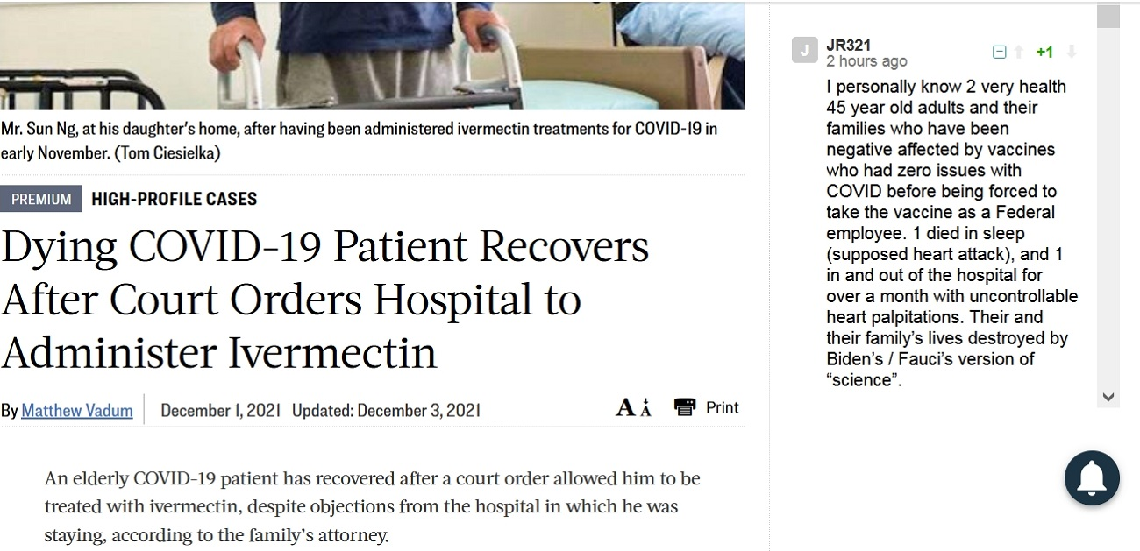
Thoughtfully, we discover that the family attorney saved this man from being dosed with remdesivir. Dr Anthony FAUCI knows and knew, citing the Ebola Study that remdesivir was removed after six months for being the lead killer in the Study.
Here is a description of the FAUCI FURNACE. The hospital and county crematoriums are being utilized to dispose of dead bodies. The funeral and memorial services homes are badly overburdened too.
Since the symptoms of the NAV inoculation are being labeled COVID and Variant infections the executions are registered as COVID ward patients dying and these COVID Wards are generally replacing the Maternity Wards, because the NAV destroys the womb.
The Japanese rat study proved that the express cells, the lipid nanoparticles target the ovaries and bones.
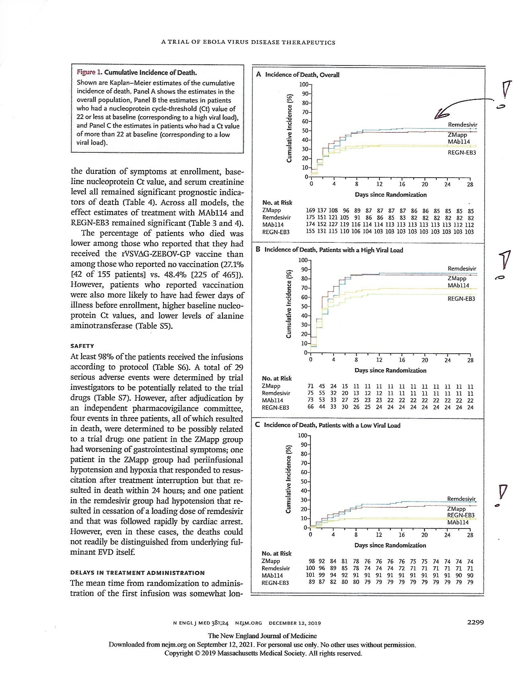
Therefore, it is concluded and in coherence with the comment in the screen shot that COVID is not victimizing people. The true pathogen is the spike protein in the NAV (nucleic acid vaccines). Furthermore, Dr Anthony FAUCI has been murdering COVID patients, starting with the elderly in order to propagate fear so that people would accept the delusion that COVID is spreading and mutating when the active pathogen is spike proteins thereof living, mutating and reproducing, primarily in the cells lining the circulatory system.
In Europe the same murder and fear mongering is done with Midazolam. Midazolam is a pre-operation sedative used to still the heart and calm anxiety prior to administering anesthetic for surgery. The dosage used for alleged COVID victims is fatal, around ten times that used for calming before a surgical operation. On this note tromethamine is being added to vaccines administered to children to stabilize their little hearts while they react. Specifically, under duress the blood becomes acidic enough to promote a heart attack and the tromethamine and tromethamine hydrochloride are added so that the young transhuman can be sent away from the inoculation without incident. Doc 40 in the Northern Alabama USDC 21-cv-702 suit admits to the use of tromethamine for children's inoculation Doc 40-2 page 3 of 8.
WHAT ARE THE INGREDIENTS IN THE VACCINE?
The vaccine includes the following ingredients: mRNA, lipids ((4-hydroxybutyl)azanediyl)bis(hexane-6,1-diyl)bis(2-hexyldecanoate), 2 [(polyethylene glycol)-2000]-N,N-ditetradecylacetamide, 1,2-Distearoyl-sn-glycero-3-phosphocholine, and cholesterol), tromethamine, tromethamine hydrochloride, sucrose, and sodium chloride.
In both America and Europe these drugs are administered with the intent to keep the masses believing that people are dying of COVID and Variants thereof, when it is plain that mutations are occurring to the spike proteins on the surface of the capsid, and the same spike proteins are the pathogen, synthesized to reproduce in the injected "vaccines". The virus in natural form never enters the bloodstream nor do the spike proteins cleave from the capsid and the natural virus is therefore innocent of all the coagulopathy.
More than three doctors have detected LEGION, hidden very cleverly inside the vaccine vials. There are contents and components that are completely undetectable in vials that have been adherent to the Temperature Chain rules. But after warming and exposure to light the hidden or camouflaged components appear under the microscope. Aside from LEGION, a synthetic parasite invented and patented by MIT, there is graphene hydroxide and graphene oxide, both highly toxic and poisonous, and neither is listed as an ingredient in any of the NAV vaccines. This deception is developed through a juxtaposition with the Comirnaty vaccine in Europe being approved in the USA, but not administered in the USA. This argument is eloquently developed by Public Health and Medical Professionals for Transparency v Food and Drug Administration (PHMPT v FDA) in case 21-cv-1058 USDC Northern Texas. The FDA approves Comirnaty and then broad swipes that approval falsely by saying that all the ingredients in all the COVID vaccines are the same and interchangeable. At the heart of this shell game is that anything that has not been approved by the FDA can contain anything; so all the vaccines administered in America are not approved except by a false declaration of uniformity and the various vaccines can and do contain anything the manufacturers decide to put in them - like graphene and LEGION synthetic parasites. Snippets from PHMPT v FDA reveals a mouthful:
On August 23, 2021, the FDA approved the Pfizer-BioNTech COVID-19 Vaccine,
marketed as Comirnaty (the “Pfizer Vaccine”) for individuals 16 years of age and older.

For example, on June 1, 2021, a group of 27 clinicians and scientists, including professors from Harvard Medical School and the UCLA School of Public Health, and members of PHMPT, filed a Citizen Petition13 with the FDA, claiming that the available evidence for licensure of the Pfizer Vaccine “is simply not mature enough at this point to adequately judge whether clinical benefits outweigh the risks in all populations.”

At this point in time the only FDA approved COVID Vaccine is marked and marketed as Comirnaty while there are several other vaccines, even by Pfizer-BioNTech being injected into people that are not Comirnaty at all. People are left to assume that since the ingredients of Comirnaty are set in the FDA approval, that all the other COVID vaccines are the same, with the same ingredients.
In one inquiry, when pressed one vaccine manufacturer added "water" to their list of ingredients. This is very suspicious that they would be hiding water, or that they forgot to list it in the original ingredients list. USDC Northern Alabama case #21-cv-702 reveals throughout Doc 40 the shell game, how CDC, WHO and BIDEN use COMIRNATY as a buzzword allowing juxtaposition of any COVID "vaccine" to be injected in the USA without regulation of the contents.
These facts and Final Judgment already in place authorize the euthanasia of the fear inoculum as it poses a very real and present danger to the living.
Detailed Description of the Invention

Isolating the Dr. Franc ZALEWSKI estimation of LEGION at 2.5 mm per antenna one finds the exact harmonic frequency in the 5G range at 5.228378 GHz. The LEGION synthetic life form builds Elon MUSK a high temperature superconductive quantum supercomputer for his QFS - Quantum Financial System, defeating the liquid nitrogen temperatures required for traditional qubits to remain coherent in their entanglement. Elon has hijacked the nervous systems of, for example 75% (reported) American inoculated transhumans. This phase conjugation dimple represents the spike protein will to survive by instinct.
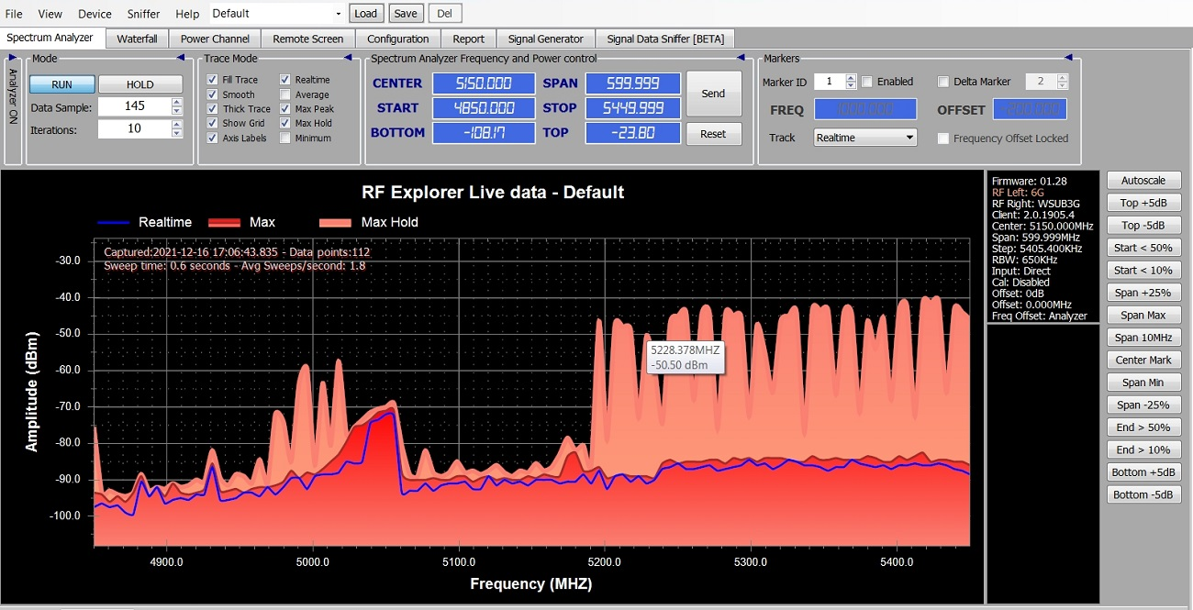
The distant harmonic of 153 and other cell death signals are easily modulated on this LEGION harmonic to override Elon's hijacked quantum computer, killing off the host transhumans; a rough estimation at four billion former people.
The Bishop Castle Colorado antennae array is symbolic of love, being charged by the family oriented visitors over the years activating the millions of stones collected and carefully placed by James Roland BISHOP in trust - CASTLE CHURCH - For the Redemption of the Office BISHOP. This transmission utility has accessed the Van Allen Belt for uniform global transmission throughout Spaceship Earth.
As explained in the Final Judgment NASA has supplied the genetic sequence reference to a wide range of pathogens.
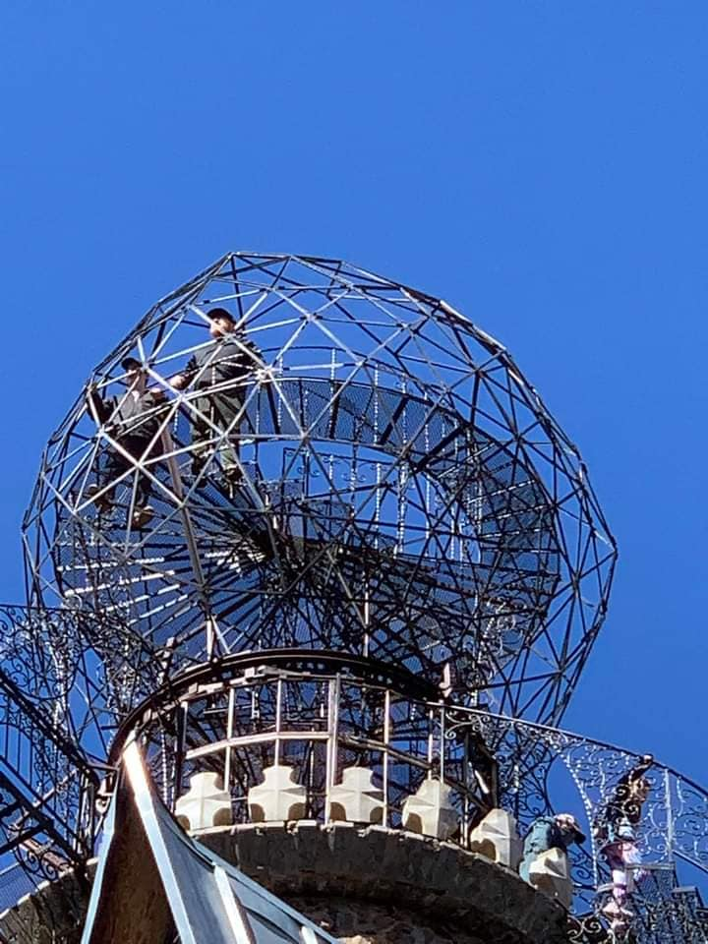

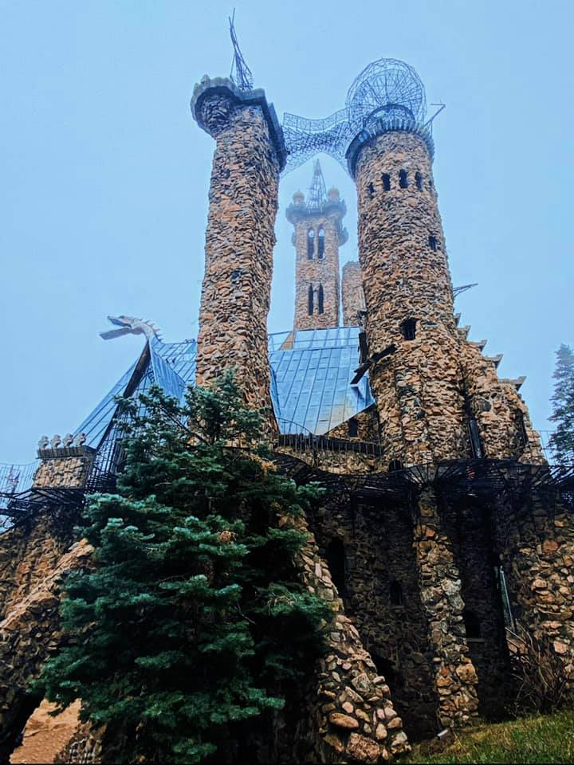

Summary of the Invention
Elon MUSK in conjunction with other Globalist planners (Great Reset) like Stephan MERGENTHALER, Klaus SCHWAB and Bill GATES has devised a bypass for waiting on a truly high temperature superconductor for his Quantum Financial System. Elon proceeds according to his belief that hijacking massive numbers of human nervous systems in tandem under one carrier frequency he can inject financial transaction information as a quantum supercomputer. Utilizing LEGION camouflaged into the NAV inoculated worldwide these globalists and big pharmaceutical companies have murdered (rewritten the genetic code for) approximately half the human population by installing the 2.5 mm antennae array into the transhuman network. Dr. Ryan COLE of the Mayo Clinic has noted a 20x increase in endothelial (uterus) cancer for women who have inoculated the NAV and therefore the termination of transhuman spread is necessary to stabilize The Culling now, rather than later. Teratogenicity is a wild card that will keep culling for some undetermined time yet.
This invention has already gone into effect to destabilize coherence and entanglement, for quantum decoherence to destabilize all superposition in Elon's biological (carbon based) machine. Additionally, that the NAV in any one injection severely reduces the amount of heartbeats left in the inoculated (now) transhuman is becoming more and more difficult to ignore and deny, daily. This transhuman population is already dead, in fact these (once) people have become something subhuman in fear, not love, deprived of dopamine in the substantia nigra (midbrain) and so Elon's Biological Quantum Supercomputer is built for failure. The irony is that without spirituality the transhumans lack capacity as superconductive medium forming qubits. To highjack the community nervous system of the masses with LEGION and call it "ownership" is fraud - watch https://tinyurl.com/OwnTheQFS about Bishop Castle Colorado at Pueblo, Jim BISHOP's home and base for Bishop Castle, Colorado - the entire NAV inoculation is without any informed consent. If the people only knew they were no longer people, that would lead to the realization they never had the keys to open up the Ledger. The QFS (Quantum Financial System) is built on sand.

The first Cube Sum Number Lock after 1. This initiates the natural cohesion and superposition of the Meissner Field in the redeemed third ventricle upon which I invented Artificial Intuition in early 2028. Opposition was skeptical and quite shocked that the first application was commercial flight control. The Cube Sum Number Locks - 153 = 1³ + 5³ + 3³ = 1 + 125 + 27 = 153; 1, 125, 370, 371 and 407.

