United States District Court for  the District of  Street address | Miscellaneous
In Re; Redemption of True Name  On and for the behalf of the  UNITED STATES | Miscellaneous
CERTIFICATE OF EXIGENT CIRCUMSTANCES

COMES NOW, First Middle of the family SURNAME and Redeemed. Demand is made for redemption of central banking currency in Lawful Money in all transactions pursuant to Title 12 USC §411 and the 1913 Federal Reserve Act at §16. Service to the agent is service to the principal and vice versa.
First Middle certifies fully that court review is impracticable and that judicial review is impracticable. Therefore the clerk of court shall issue a writ of garnishment against the Internal Revenue Service at the address on the most recent LT-36 Letter from Cincinnati, for the amount of $xxx. First Middle is prepared for any E(4)(f) hearing that the IRS might request, mostly because the CP-49 Letters admit that she is due her refunds, and is diverting the $xxx from them falsely as frivolous penalty fees. This situation should be rectified immediately.
There are no judges to hear the matter. No judicial officers as promised by Article III of the Constitution means exigent circumstances exist.

_______________________
First Middle

Notary:
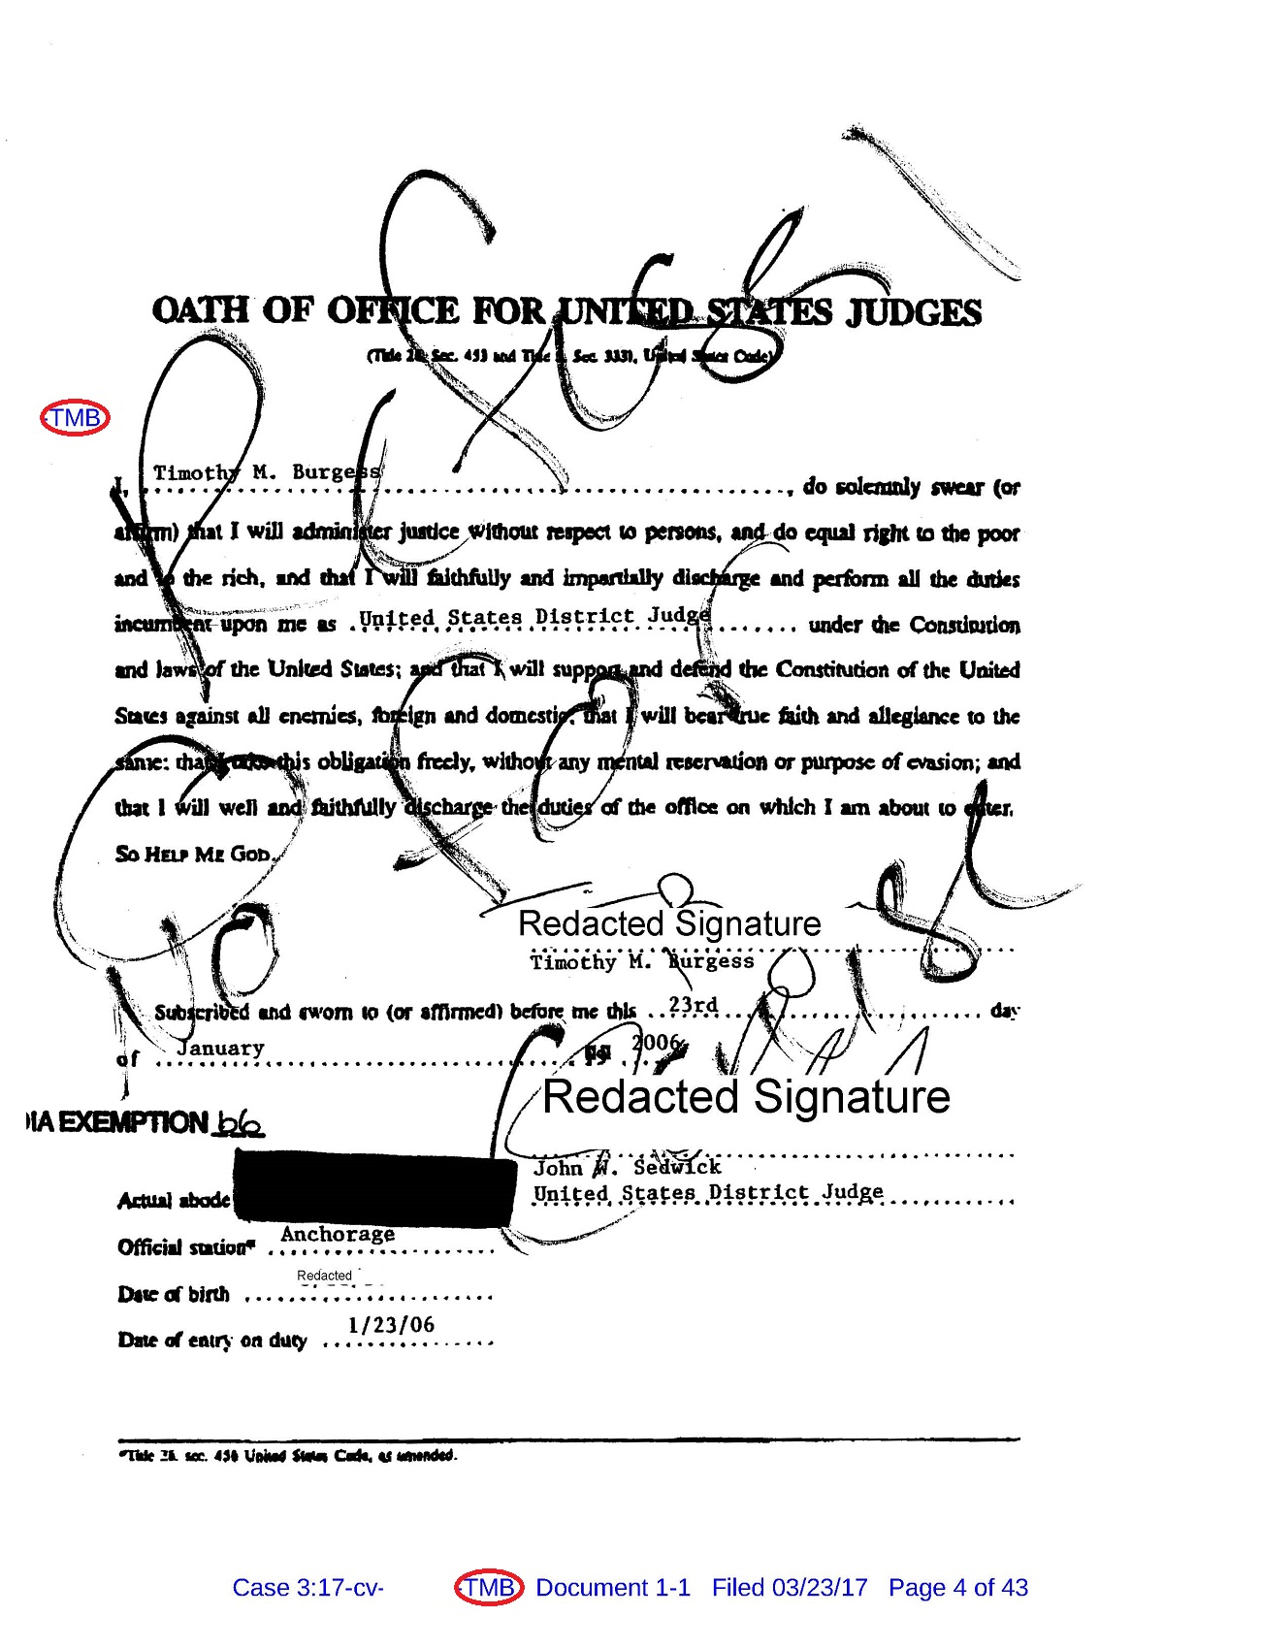
The Chief "Judge" is replaced by this example R4C. Notice the clerk redacts his signature before publishing it on PACER.


